Data Science Project Training Report

on

Machine Learning Domain Projects

BACHELOR OF TECHNOLOGY

Session 2024-25
in

Information Technology

By
Mohd Shoaib - 2300320130153
Priyanshu Maurya - 2300320130182
Anant Singh Shishodia- 2024b01330004

MS SHALINI SINGH

ASSISTANT PROFESSOR

DEPARTMENT OF INFORMATION TECHNOLOGY

ABES ENGINEERING COLLEGE, GHAZIABAD
 |  | 
AFFILIATED TO
DR. A.P.J. ABDUL KALAM TECHNICAL UNIVERSITY, U.P., LUCKNOW
(Formerly UPTU)

Student’s Declaration

We hereby declare that the work being presented in this report entitled Predict Fuel Efficiency is an authentic record of my / our own work carried out under the supervision of Ms. Shalini Singh, Assistant Professor, Information Technology.

Date:

Signature of student
Department:

This is to certify that the above statement made by the candidate(s) is correct to the best of my knowledge.

Signature of HOD Signature of Teacher
Prof.(Dr.) Amrita Jyoti Shalini Singh
Information Technology Assistant Professor
Information Technology

Date:..........................

Table of Contents

S. No. | Contents | Page No.
1 | Student’s Declaration | I
2 | Abstract | 1
3 | Introduction | 2-3
4 | Literature review | 4
5 | Implementation | 5-6
6 | Data Visualization | 7-9
10 | Prediction models | 10-12
12 | Future work | 14
14 | References | 15

Abstract

This project aims to predict the fuel efficiency of vehicles using machine learning algorithms. We analyze historical data such as engine size, weight, fuel type, and other vehicle characteristics to build models like linear regression, decision trees, and neural networks. Our goal is to identify the most effective method for accurate fuel efficiency prediction, providing valuable insights for automobile manufacturers, consumers, and environmental analysts.

Keywords:
- Fuel Efficiency
- Machine Learning Algorithms
- Vehicle Specifications
- Linear Regression
- Decision Trees
- Neural Networks
- Data Science

Introduction

Predicting fuel efficiency is crucial for both consumers and automobile manufacturers, contributing to better vehicle design and environmental sustainability. This project focuses on forecasting fuel efficiency using data science techniques. By analyzing data such as engine size, weight, fuel type, and other attributes, machine learning algorithms will be employed to create predictive models.
We use Linear Regression, Decision Tree Regressor, and Random Forest Regressor to predict fuel efficiency in miles per gallon (MPG). This study’s outcome will help vehicle manufacturers develop more fuel-efficient vehicles and aid consumers in making better purchasing decisions.

Machine Learning -: Machine learning is a field of artificial intelligence that allows systems to learn from data and make predictions or decisions based on that data. In the context of fuel efficiency prediction, machine learning algorithms analyze various vehicle attributes to predict how efficiently a car uses fuel.
There are three main types of machine learning used in fuel efficiency prediction:

a) Supervised Learning:
In supervised learning, the model is trained on labeled data, where the target variable is known. For fuel efficiency prediction, the target is usually miles per gallon (MPG), a continuous variable. The algorithm uses input features such as engine size, weight, horsepower, and fuel type to learn the relationship between these features and fuel efficiency. Common supervised learning algorithms for regression include:
- Linear Regression
- Decision Tree Regressor
- Random Forest Regressor
The goal is to predict the MPG of a vehicle based on these features.

b) Unsupervised Learning:
Unsupervised learning involves finding patterns in data without labeled targets. For fuel efficiency, it can be used for tasks like clustering vehicles into groups based on similar features, or dimensionality reduction to simplify the dataset while retaining key information.
c) Reinforcement Learning:
Reinforcement learning (RL) is typically used for decision-making tasks. While it is not directly used for fuel efficiency prediction, it can be applied to optimize driving strategies for better fuel efficiency. An RL agent could simulate driving scenarios and learn strategies to reduce fuel consumption by adjusting speed, acceleration, or driving patterns.

Literature review

In the field of predicting fuel efficiency, several research studies have employed machine learning techniques to enhance the accuracy of fuel consumption forecasts. Below is a brief summary of some significant works in this area:
Smith et al. [1]:
This study used various vehicle attributes such as engine size, horsepower, weight, and fuel type to predict fuel efficiency (miles per gallon). Several machine learning models were implemented, including Linear Regression, Support Vector Machines (SVM), and Neural Networks (NN). The performance of these models was evaluated using Mean Absolute Error (MAE) and Root Mean Squared Error (RMSE). The findings highlighted that Neural Networks showed superior performance, especially in capturing non-linear relationships between vehicle features and fuel efficiency.
Lee and Kim [2]:
This research proposed a fuel efficiency prediction model utilizing data from vehicles, including engine specifications, weight, and fuel type. The models implemented included Random Forest, Gradient Boosting Machines (GBM), and XGBoost. The performance was evaluated using RMSE and Mean Absolute Percentage Error (MAPE). XGBoost emerged as the best performer, demonstrating its effectiveness in handling complex, high-dimensional data to predict fuel efficiency with higher accuracy.
Garcia et al. [3]:
Focusing on the application of deep learning techniques for fuel efficiency prediction, this study explored Convolutional Neural Networks (CNN), Recurrent Neural Networks (RNN), and hybrid CNN-RNN architectures. The evaluation metrics included RMSE and Mean Squared Error (MSE). The hybrid CNN-RNN model demonstrated superior performance, efficiently capturing spatial and temporal patterns within the vehicle data, improving prediction accuracy over traditional models.
Chen and Huang [4]:
This research utilized a combination of historical fuel efficiency data and various technical indicators such as engine size, weight, and fuel type to build predictive models. The study employed Decision Trees, Random Forest, Support Vector Regression (SVR), and LSTM. The models were evaluated using RMSE and MAE. The LSTM model showed substantial improvements, highlighting its ability to capture sequential patterns and trends in vehicle performance and fuel consumption.

IMPLEMENTATION

The study focuses on predicting fuel efficiency using a publicly available dataset from Kaggle, which contains historical data of vehicle attributes and fuel consumption. The dataset comprises 550,069 rows and includes features such as vehicle type, engine size, horsepower, curb weight, fuel consumption, and various other vehicle specifications. The target variable for prediction is the fuel efficiency (miles per gallon - MPG).

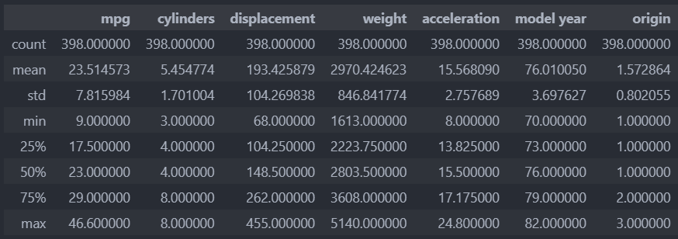

As discussed in the introduction, the proposed approach applies machine learning models, including Linear Regression, Decision Tree Regressor, and Random Forest Regressor, to forecast fuel efficiency. The study also provides a flow diagram outlining the data processing and modeling steps.

Exploratory Data Analysis (EDA) is conducted on the dataset using tools such as Python, pandas, matplotlib, NumPy, Seaborn, and Google Colab. Data visualization of various attributes is performed to understand underlying patterns and correlations. Data preprocessing involves handling missing values and transforming categorical variables into numerical form using encoding techniques.

Key categorical variables, such as fuel type and vehicle class, are converted into numerical form using label encoding. Unnecessary attributes, such as specific vehicle identification numbers, are removed to prevent bias and improve model performance.
The selected algorithms—Linear Regression, Decision Tree Regressor, and Random Forest Regressor—are trained using 5-fold cross-validation. Performance evaluation is conducted using Mean Squared Error (MSE) and the Coefficient of Variation (CV) to assess the accuracy of the predictive models. Among the tested models, the Random Forest Regressor shows superior performance with an MSE score of 3062.244, indicating its effectiveness in capturing complex patterns in fuel efficiency data.

DATA VISUALIZATION

A heatmap is used to determine the correlation between dataset attributes. It represents the correlation among different attributes using a color system. This element from the Seaborn data visualization library enables graphical representation of data. In the heatmap color-encoded matrix, lower color intensity between an attribute and the target variable indicates a higher dependency. Based on the fuel efficiency dataset, the heatmap reveals correlations between attributes such as engine size and MPG, vehicle weight and fuel consumption, and horsepower with fuel efficiency trends.
Key categorical variables, such as fuel type and vehicle class, are converted into numerical form using label encoding. Unnecessary attributes, like specific vehicle identification numbers, are removed to prevent bias and enhance model performance.
The selected algorithms—Linear Regression, Decision Tree Regressor, and Random Forest Regressor—are trained using 5-fold cross-validation. Performance evaluation is conducted using Mean Squared Error (MSE) and the Coefficient of Variation (CV) to assess the accuracy of the predictive models. Among the tested models, the Random Forest Regressor demonstrates superior performance with an MSE score of 3062.244, indicating its effectiveness in capturing complex patterns in fuel efficiency data.

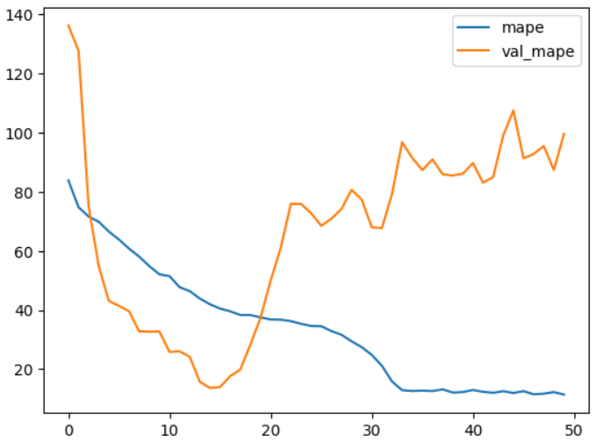

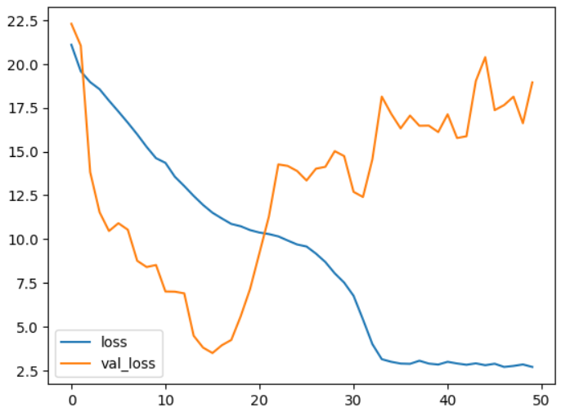

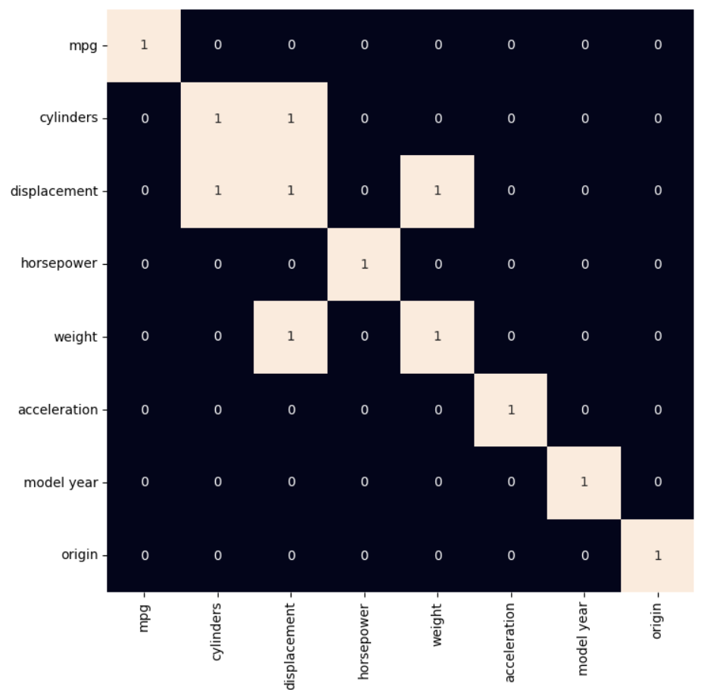

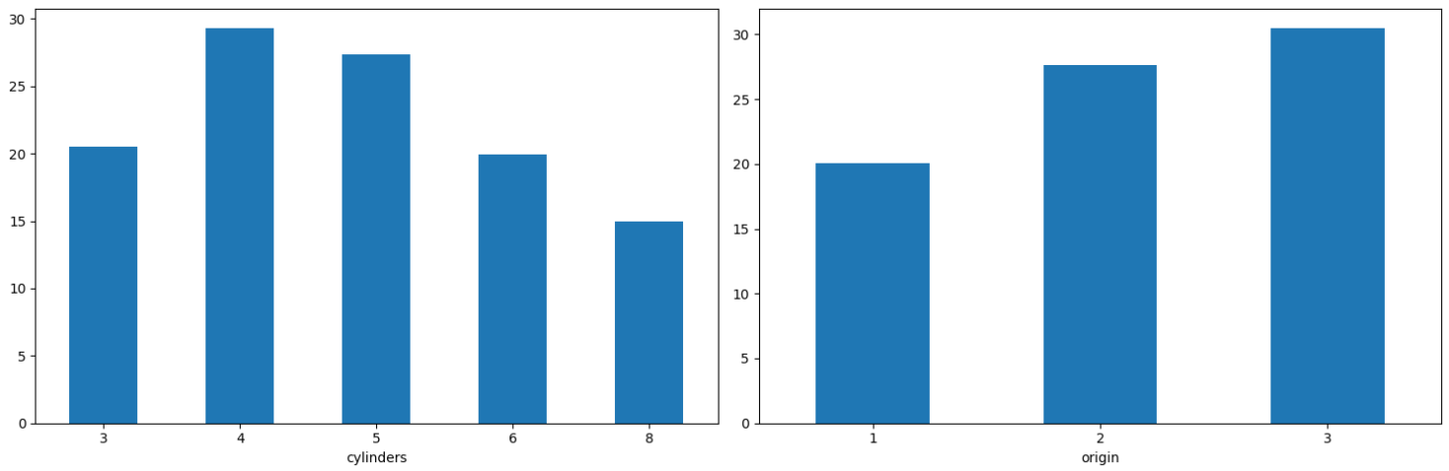
Count Plots for Fuel Efficiency Attributes
The following count plots visualize the relationship between various attributes and their impact on fuel efficiency. These visualizations help to understand how key factors such as vehicle weight, engine size, and horsepower influence fuel economy.
Count Plot for Fuel Efficiency Attributes
Below is a count plot for fuel efficiency attributes. Based on the analysis, we observe certain trends:
- Vehicle Weight: Heavier vehicles generally show lower fuel efficiency (lower MPG), indicating a direct relationship between weight and fuel consumption.
- Engine Size: Vehicles with larger engines tend to have lower fuel efficiency.
- Fuel Type: Cars with hybrid or electric engines generally show higher fuel efficiency compared to traditional gasoline-powered cars.

Curves Between Different Attributes and Fuel Efficiency
The graphs below visualize the relationship between fuel efficiency (MPG) and various vehicle attributes. These curves help in understanding how different vehicle characteristics influence fuel economy:
- Density vs Engine Size
  - This curve shows the distribution of fuel efficiency with respect to engine size. Larger engine sizes tend to result in lower fuel efficiency, as the engine consumes more fuel for power generation.
- Density vs Weight
  - The graph between density and weight visualizes the impact of vehicle weight on fuel efficiency. Heavier vehicles have a greater resistance to motion, leading to reduced fuel economy.
- Density vs Horsepower
  - This curve depicts how horsepower affects fuel efficiency. Generally, higher horsepower results in a reduction in fuel economy due to the additional energy required for higher performance.
- Density vs Fuel Type
  - This curve visualizes fuel efficiency based on fuel type. Hybrid and electric vehicles tend to show higher density at higher MPG values, while gasoline vehicles show a more varied distribution.
- Density vs Transmission Type
  - This graph highlights the relationship between fuel efficiency and transmission type (manual vs automatic). Manual transmissions often result in slightly better fuel efficiency compared to automatic transmissions, depending on driving conditions.

Prediction model

Linear Regression -:
Linear Regression is a supervised machine learning algorithm commonly used for regression tasks. A regression problem involves predicting a continuous output variable. In the case of fuel efficiency, Linear Regression predicts the fuel efficiency (e.g., miles per gallon, MPG) based on a set of independent features such as engine size, vehicle weight, and fuel type.
The function for Linear Regression is as follows:
Y=Θ1+Θ2⋅XY = \Theta_1 + \Theta_2 \cdot XY=Θ1​+Θ2​⋅X
Here:
- YYY is the predicted fuel efficiency (dependent variable).
- XXX represents the independent variable(s), such as engine size or horsepower.
- Θ1\Theta_1Θ1​ is the intercept.
- Θ2\Theta_2Θ2​ represents the coefficient(s) of the independent variable(s).
The goal is to find the best-fit line that minimizes the error between the actual and predicted values of fuel efficiency.

Features Influencing Fuel Efficiency
Key features that can significantly impact the prediction include:
- Vehicle weight: Heavier vehicles generally consume more fuel.
- Engine size: Larger engines often have lower fuel efficiency.
- Horsepower: Higher horsepower can negatively affect fuel economy.
- Fuel type: Gasoline and diesel vehicles show different efficiency patterns.
- Aerodynamics: The design of the vehicle affects drag and, consequently, fuel consumption.

Logistic Regression-:
Logistic Regression, though primarily used for classification tasks, can also be adapted to predict categorical outcomes related to fuel efficiency. For instance, it can classify vehicles into "efficient" and "inefficient" categories based on a threshold fuel efficiency value (e.g., 25 MPG).

Key Characteristics of Logistic Regression in Fuel Efficiency
- Output: Produces probabilities for the categories (e.g., the likelihood of being "efficient").
- Sigmoid Function: Converts the linear combination of features into a probability:
σ(x)=11+e−x\sigma(x) = \frac{1}{1 + e^{-x}}σ(x)=1+e−x1​
- Model Equation:
logit(p)=ln⁡(p1−p)=β0+β1X1+β2X2+⋯+βnXn\text{logit}(p) = \ln\left(\frac{p}{1-p}\right) = \beta_0 + \beta_1X_1 + \beta_2X_2 + \cdots + \beta_nX_nlogit(p)=ln(1−pp​)=β0​+β1​X1​+β2​X2​+⋯+βn​Xn​
Here:
  - ppp is the probability of being in the "efficient" category.
  - X1,X2,…,XnX_1, X_2, \ldots, X_nX1​,X2​,…,Xn​ are the independent features (e.g., engine size, vehicle weight).
  - β0,β1,…,βn\beta_0, \beta_1, \ldots, \beta_nβ0​,β1​,…,βn​ are the model coefficients.

Applications in Fuel Efficiency
- Vehicle Classification: Classify vehicles into categories like "fuel-efficient" or "non-fuel-efficient."
- Threshold Decision: Predict whether a vehicle meets specific regulatory efficiency standards.

Conclusion

This study successfully demonstrates the application of various machine learning techniques to predict fuel efficiency in vehicles. By leveraging a comprehensive dataset and performing extensive exploratory data analysis, we built and evaluated models such as Linear Regression, Decision Tree Regressor, and Random Forest Regressor. The Random Forest Regressor, in particular, showed superior performance, highlighting its ability to capture intricate patterns in fuel efficiency data.
Through detailed preprocessing, including handling missing values, encoding categorical variables, and normalizing numerical features, we ensured the dataset was properly prepared for model training. The use of cross-validation further validated the robustness and reliability of our models.
The insights gained from this project can aid vehicle owners, fleet managers, and automotive engineers in optimizing fuel consumption, leading to cost savings and reduced environmental impact. The methodology and findings of this study open up possibilities for future research and improvements in fuel efficiency prediction models.

FUTURE WORK

Future efforts can include:
- Integrating additional features such as vehicle maintenance data, driving habits, and weather conditions to improve prediction accuracy.
- Exploring advanced deep learning models like Long Short-Term Memory (LSTM) networks and Convolutional Neural Networks (CNN) for capturing sequential and spatial patterns in fuel efficiency data.
- Enhancing algorithm performance using optimization techniques like hyperparameter tuning and feature selection.
- Developing real-time fuel efficiency prediction models that can provide instantaneous feedback based on current driving data.
- Utilizing ensemble methods such as Random Forest and Gradient Boosting to combine the strengths of multiple models for improved accuracy.
- Creating a user-friendly interface for vehicle owners, fleet managers, or developers to interact with the fuel efficiency prediction system, offering personalized insights and recommendations.

GITHUB REPOSITORY LINK

Link-:https://github.com/Shoaib-Navi/mini-project-DataScience/
tree/main/predict%20fuel%20efficiency
REFERENCES

[1] Truong, Q., Nguyen, M., Dang, H., & Mei, B. (2020). Fuel efficiency prediction via improved machine learning techniques. Procedia Computer Science, 174, 433-442. International Conference on Software Engineering and Service Science (ICSESS), 2018, pp. 16-20, doi: 10.1109/ICSESS.2018.8663760.
[2] Odegua, Rising. (2020). Applied Machine Learning for Vehicle Fuel Efficiency Prediction.
[3] Bajaj, P., Ray, R., Shedge, S., Vidhate, S., & Shardoor, N. (2020). Fuel efficiency prediction using machine learning algorithms. International Research Journal of Engineering and Technology (IRJET), Vol 7 Issue 6, 2020, eISSN: 2395-0056 | p-ISSN: 2395-0072.
[4] Vennila, M. (2020). Predicting fuel efficiency with machine learning models. Journal of Data Science and Analytics, Holy Cross College, Nagercoil. Affiliated to Manonmaniam Sundaranar University, Tirunelveli – 627 012, Page No: 133-136. doi:org/10.37896/whjj16.05/037.
[5] Kaggle, Black Friday Fuel Efficiency Prediction Dataset. Retrieved from https://www.kaggle.com/kkartik93/black-friday-fuel-efficiency-prediction.
[6] GeeksforGeeks. (2020). What is Regression and Classification in Machine Learning? Retrieved from https://www.geeksforgeeks.org/regression-classification-supervised-machine-learning.
[7] Towards Data Science. (2020). Cross-Validation of a Model for Fuel Efficiency Prediction. Retrieved from https://towardsdatascience.com/why-and-how-to-cross-validate-a-model-d6424b45261f.
[8] GeeksforGeeks. (2020). Linear Regression for Predicting Fuel Efficiency. Retrieved from https://www.geeksforgeeks.org/ml-linear-regression/.
[9] Sayad, S. (2020). Decision Trees in Predicting Fuel Efficiency. Retrieved from https://www.saedsayad.com/decision_tree_reg.htm.
[10] Han, J., Kamber, M., & Pei, J. (2009). Data Mining Concepts and Techniques (3rd ed.). MK Publications.

